Passenger Survey Analysis
Introduction
The data we have been looking at concerns the passenger survey conducted in 2012 from SFO, where customers were asked a few questions – how many locations they considered to be ‘dirty’ at the airport, how long they stayed at the airport (from entry to take off – not necessarily due to delays), whether their flight was a domestic flight or international, how many times they had flown out of SFO in the previous twelve months, and finally whether they approved of the airport or not.
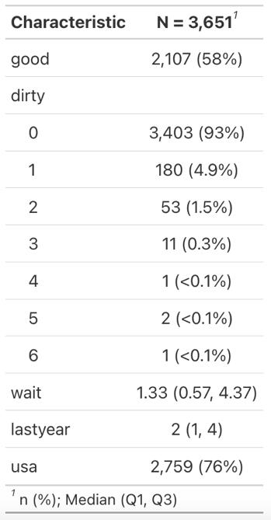
Initial Data Analysis:
This table gives us the basic stats from the survey, where a slight majority of participants approved of the airport – although we would hope to increase the 58% approval rating. In terms of cleanliness, clearly the vast majority (93%) of people did not think anywhere in the airport was dirty. The median length of the passengers stay at the airport was 1.33 hours, and with the quartiles shown (0.57, 4.37), we see that half of all customers spend between 34 minutes and 4 hours 22 minutes at the airport, which is quite a large variety. For the number of flights each passenger had taken from SFO in the last year, the summary statistics don’t show the whole picture but looking at the graph of the variable “lastyear” below, we can see an overwhelming majority of passengers have taken at least a flight in the previous 12 months, only 33 people answering that this was their first flight from SFO in the last year. The last variable we have is the domestic vs international flight question – over three quarters of all passengers surveyed were at SFO for a domestic flight.
Figure 1
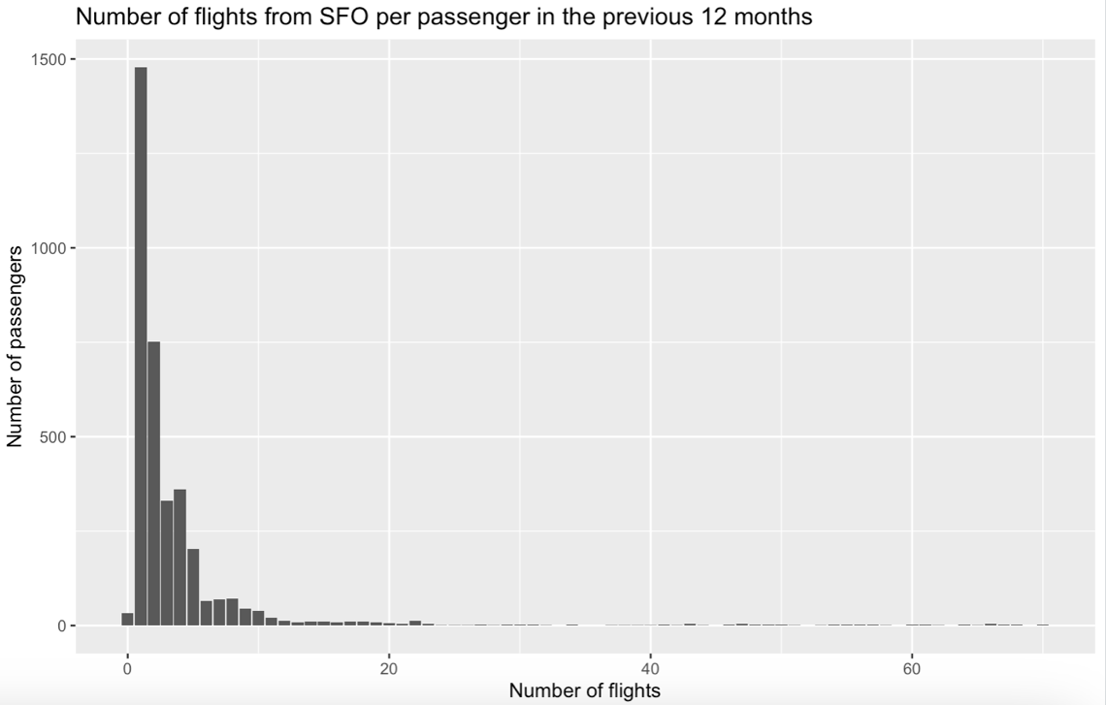
Figure 2

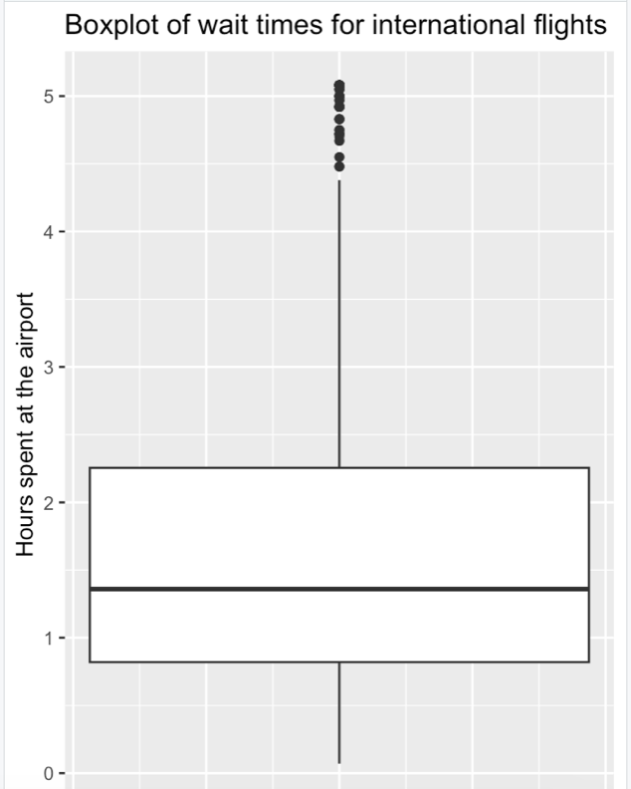
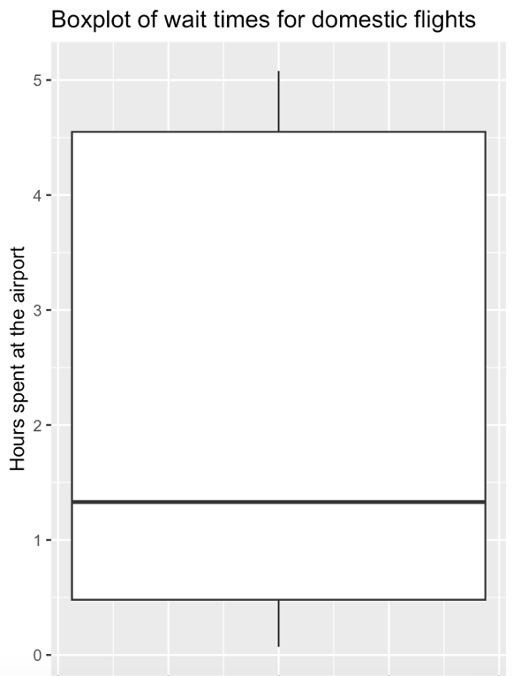
Below we have box plots of the wait times, for both domestic and international flights. The median in both plots are very similar – 1.36 hours for internationals and 1.33 for domestic – however we see that the lengths of stay for international passengers are clustered far closer together than for domestic flights. The binary outcome of good in both cases, comes out to 58% - exactly the same for both international and domestic flights! This suggests that the nature of flight has little to no bearing on whether a customer has a good experience at SFO or not.
Figure 4
Figure 3

Logistic Regression Models:
For the logistic regression model, using R, we use the following code:
model <- glm(good ~ dirty + wait + lastyear + usa, data=df, family = binomial)
Which gives us a summary of:

Call:
glm(formula = good ~ dirty + wait + lastyear + usa, family = binomial,
data = df)

Coefficients:
Estimate Std. Error z value Pr(>|z|)
(Intercept) 0.510979 0.077551 6.589 4.43e-11 ***
dirty -0.826194 0.108218 -7.635 2.27e-14 ***
wait -0.074570 0.018617 -4.006 6.19e-05 ***
lastyear -0.003049 0.004441 -0.686 0.492
usa 0.060701 0.079427 0.764 0.445
---
Signif. codes: 0 ‘***’ 0.001 ‘**’ 0.01 ‘*’ 0.05 ‘.’ 0.1 ‘ ’ 1
(Dispersion parameter for binomial family taken to be 1)
Null deviance: 4974.2 on 3650 degrees of freedom
Residual deviance: 4883.5 on 3646 degrees of freedom
AIC: 4893.5
Number of Fisher Scoring iterations: 4

For other logistical regression models, we can choose which of the four predictor variables (dirty, wait, last year, usa) we include and which we do not, this would give us 15 possible models with at least one predictor variable in to choose from. Looking at just a few of the models we could use:

Taking a model with predictors: (dirty, wait, usa) our AIC comes to 4892
Taking a model with predictors: (dirty, wait) our AIC comes to 4890.5
Taking a model with predictors: (dirty, wait, last year) our AIC comes to 4892.1
Taking a model with predictors: (dirty, usa) our AIC comes to 4906.4
Taking a model with predictors: (wait, usa) our AIC comes to 4964.4

We can try other models, but from the original model, we see that the variables “dirty” and “wait” are the most useful in predicting whether a customer rated the airport as “good” or not. This is further confirmed by the fact that the model using only those two variables has the lowest AIC value (Akaike Information Criterion) and this suggests that using a model with “dirty” and “wait” as the only predictor variables will give the best balance between accuracy of model and complexity (number of predictor variables). This lines up with what we saw above as the “usa” variable had little effect on whether passengers approved of their trip to the airport or not, similarly it seems the number of flights taken from SFO in the last year also had minimal impact on the approval of passengers.

Conclusion and Future Plans:
Using this information, and the logistical model, we can conclude that the best way to improve customer satisfaction would be to ensure cleanliness at all locations in the airport. A suggestion for the next survey, would be to find out more about how the customers are spending their time at the airport, rather than the overall time at the airport, breaking down into “waiting at the gate” and “time checking in/going through security” may give us a better idea into where SFO should focus their efforts in improving the customer experience.

